Table of Contents

Mini Complete SEO Audit
Plum Plumbers
______________________________________________

By Stuart Marsden

August 2026
Table of Contents
Key
Technical Audit
Introduction
Preferred Domain & Trailing Slashes
301 Redirects & 404 Errors
Google Analytics & Google Search Console
Google Data Analysis
Speed Test & Performance
Security Check & Malware Scan
Plugins
Content Audit
Introduction
Existing & Competitor Gap
Research
Cannibalisation
On-Page SEO
Site Structure, Linking & Sitemap
On-Page Content Quality
Content Ideas & Strategy
Landing Pages
Roundups
VS Competitor Articles
How-to Guides
List Posts
Guest Articles
Competitor Audit
Introduction:
Backlink Profile
1. Popularity
2. Relevancy
Ahrefs
Competitors (Ahrefs Overview)
Google My Business
Social Media
Summary & Conclusion
Areas for Improvement
technical
content
competitors
Social Media

Key

Green - Done well / trivial room for improvement
Orange - Done poorly / room for improvements
Red - Current state is detrimental to overall SEO / completely unimplemented
Blue - Our recommendation


TECHNICAL AUDIT
Plum Plumbers
______________________________________________

Technical Audit

Introduction
SEO services can play a crucial role in building visibility, brand awareness, traffic, and sales from organic search. We take an active step in understanding your business, its branding and positioning. There are over 200 ranking factors to Google’s algorithm.

Our approach focuses on targeting those factors that have the most influence, and those that will have the biggest return on investment.

A complete SEO Audit consists of three components:
- Technical / sitewide problems
- Content / on-page / page-specific problems
- Off-page / competitor problems.

This Technical Audit will deal with aspects relating to:
- The Domain (such as domain resolve problems or a lack of SSL),
- Your relationship with Google (ie. Google Analytics being set up poorly or Google My Business lacking details),
- Various Technical SEO properties (ie. slow site speed or a broken XML sitemap), and
- Wordpress specific characteristics (such as missing or outdated plugins).

We use premium tools and a methodological approach to consider a broad spectrum of metrics. We will provide you with a snapshot of the health of your website, pinpoint any problems, and suggest remedies to these problems.

This report can be used as either a basis for a retainer, or as a blueprint for your internal development team to resolve any technical issues to grow your site’s traffic.

This section reviews the domain signals that can affect trust, crawling, and duplicate-content control.
We assess the domain name, TLD, age, ownership signals, preferred version of the domain, HTTPS behaviour, and trailing slash consistency. The aim is to confirm that the site uses an appropriate domain setup, resolves cleanly to one preferred version, and does not create avoidable duplication or trust issues for search engines.

FINDINGS

- Your domain was registered on 8 August 2020 (details).
- N/A
- N/A

RECOMMENDATIONS
- None.

The next checks confirm whether Google and users are consistently sent to one canonical version of the site.

Preferred Domain & Trailing Slashes
Preferred domain refers to whether your domain has only 1 active variation. This means that you choose 1 variation of your domain and then redirect the other 3 variations to this preferred variation.

If you have multiple versions of your domain then you will not rank as well as you could (because Google will consider your content to be duplicate content, thus diluting your ability to rank).

Example:
The “root with SSL” domain was chosen to be the preferred domain for Woww, and thus all other domain variations are redirected to the preferred domain.

- “http://woww.co.za/” (This is called the root domain)
- “http://www.woww.co.za/” (This is the www domain)
- “https://www.woww.co.za/” (This is the www with SSL)
- “https://woww.co.za/” (This is the root with SSL)

Trailing slashes refers to whether your URLs end with a “/” or not, and whether you are consistent in your approach regarding trailing slashes.

Poorly implemented trailing slashes can be extremely damaging because Google views (e.g.) https://woww.co.za/about/ and https://woww.co.za/about as different pages, and so you can slip down the search results for duplicate content if you have both versions of a URL on your site.

For this mini audit, we only need to confirm whether the main domain variants and representative subpages resolve cleanly, and whether trailing slash handling could create duplicate URLs.

DATA COLLECTION

 | Trailing slashes

FINDINGS

- All 4 variations of your home URL were checked.
  - All variations redirect to your preferred URL: http://woww.co.za zzz
  - Subpages also redirect properly.
- No trailing slash issues found
- N/A
- N/A

RECOMMENDATIONS
- None

301 Redirects & 404 Errors
This section reviews whether redirects and broken URLs are creating unnecessary friction for users or search engines. We focus on the issues most likely to affect crawl efficiency, user experience, and the flow of authority through the site.
- 301 Redirects: We check whether redirected URLs are being used appropriately, and whether internal links point directly to the final destination page rather than passing users and crawlers through unnecessary redirects.
- Redirect Chains: We check whether any URLs redirect through multiple steps before reaching the final page. Long redirect chains can slow down crawling, dilute signals, and create avoidable technical complexity.
- 404 Errors: We check whether important URLs return 404 errors, whether broken pages are linked internally, and whether any missing pages should be restored, redirected, or removed from internal links and sitemaps.
- 404 Page: We check whether the site has a useful 404 page that returns the correct HTTP status, explains that the page cannot be found, and helps users continue their journey through clear navigation or links to key pages.

FINDINGS FOR 404 PAGE

- 404 Page functions adequately
  - Users can navigate back to the homepage.
- N/A
- N/A

RECOMMENDATIONS
- Including a list of pages (services) relevant to your user is a good way to include internal links and direct users to your most valuable pages.

Google Analytics & Google Search Console
 | 

Google Analytics is a free web analytics tool offered by Google to help you analyze your website traffic.

Given that your website is the central hub of your digital presence, your website is the best way to give you a holistic view of the effectiveness of all the campaigns you are running to promote your product/services online.

Google Analytics is a way to measure the site's traffic and gain insight into how users perform, where they are coming from and how they’re interacting with your site from both a holistic viewpoint all the way down to analysis of a single interaction.

Google Search Console tools and reports help you measure your site's Search traffic and performance, fix issues and make your site shine in Google Search results.

DATA COLLECTION

 | Manual tests

FINDINGS

- No data available at the time of the audit.
  - Google Analytics was set up during the audit.
- Google Search Console setup pending
- Consider setting up a data studio report, Woww can do this for you.
- N/A

RECOMMENDATIONS
- We are happy to complete this aspect of the audit at a later date (weeks / months) to cover the data acquired.

Google Data Analysis
In this section we will analyse your Google Analytics data and your Google Search Console data.

The Google Analytics data goes back 2 years (24 months) and is monthly data, while the Google Search Console data goes back 16 months and is daily data (this is a limitation of Google Search Console).

DATA COLLECTION

Google Data Analysis

FINDINGS

- No data available at the time of the audit.
  - Google Analytics was set up during the audit.
- N/A
- N/A

RECOMMENDATIONS
- We are happy to complete this aspect of the audit at a later date (weeks / months) to cover the data acquired.

Speed Test & Performance
Google has stated that page loading speed is an SEO ranking signal. Furthermore, it affects user experience - slow sites are horrible to use. You can boost your site speed by using a CDN, compressing images, and switching to faster hosting.

 | CDN  CDN is short for content delivery network, which is a system of distributed servers (network) that deliver pages and other web content to a user, based on the geographic locations of the user, the origin of the webpage and the content delivery server. This service is effective in speeding the delivery of content of websites with high traffic and websites that have global reach.

Here’s an image from CloudFlare which depicts this perfectly:
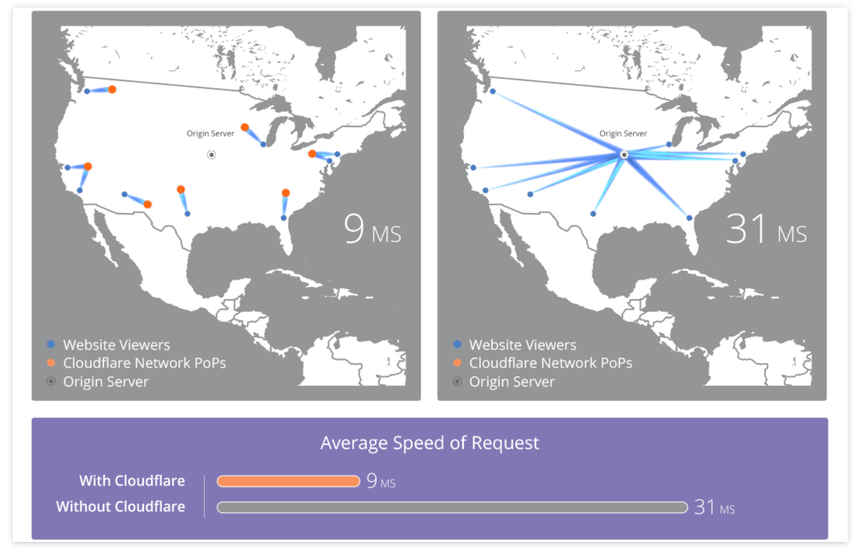
By using a CDN, like CloudFlare, when someone visits your website, the images will be loaded from the server closest to them.

We want to make sure your site doesn’t take more than 4 seconds to load: MunchWeb found that 75% of users wouldn’t re-visit a site that took longer than 4 seconds to load.

FINDINGS

Here are the current test results for the home page of the site:

Test Results | GTMetrix (SA) | Pingdom (UK) | PageSpeed Insights  (mobile + desktop)
Page Size | 2.28 MB | 2.7 MB | n/a
Load Time | 5.7s | 987 ms | 9.2s
Requests | 81 | 82 | n/a
Performance Rating | B - 73 | C - 75 | Mobile - 55  Desktop - 72
LCP | 2.1s | n/a | 2.7s
FCP | 1.4s | n/a | Mobile: 9.2s  Desktop: 0.6s
Speed index | 2.0s | n/a | Mobile: 9.2s  Desktop: 1.4s
CLS | 0 | n/a | Mobile: 0.021  Desktop: 0.001
TTFB | 215ms | n/a | Mobile: 0ms  Desktop: 10ms
*all tests were run in London servers (the closest available server option)

- Layout stability is strong. CLS is excellent at 0.021 on mobile and 0.001 on desktop. GTmetrix also records LCP at 2.1s, showing a solid foundation for performance improvements.
- The homepage is moderately heavy. It weighs 2.28–2.7MB and generates 81–82 requests. Test results also vary significantly by location and tool, indicating that page assets and delivery efficiency should be reviewed.
- Mobile performance is the priority. PageSpeed Insights gives the site a mobile score of 55/100, with FCP and Speed Index both at 9.2s; LCP is 2.7s, slightly above Google’s recommended 2.5s threshold. Mobile visitors may wait too long before useful page content appears.

RECOMMENDATIONS
- Optimise homepage imagery first: serve correctly sized responsive images in WebP or AVIF, compress source files, and lazy-load below-the-fold images. Preload the primary hero/LCP image rather than lazy-loading it.
- Reduce the number and impact of non-essential assets. Audit theme, plugin and third-party scripts; defer non-critical JavaScript, remove unused CSS/JS, and limit unnecessary font files or font weights.
- Review caching and content delivery configuration. Enable full-page and browser caching where the hosting stack supports it, and confirm that static assets such as images, CSS and JavaScript are cached effectively through the existing CDN configuration.
- Retest following implementation from a South African test location. Prioritise improving the mobile PageSpeed score, targeting LCP below 2.5s, FCP below 1.8s, and CLS below 0.1.

Security Check & Malware Scan
Often a large drop in rankings occurs when a site is hacked with Malware. The hackers use your site to generate hundreds of spammy links and pages advertising unsavoury products such as payday loans or viagra pills.



FINDINGS

We ran your site through Google Security and Sucuri Scans. These are services which check for malware and hacks.

- No malware detected by scan (Low Risk)
- No injected spam detected (Low Risk)
- No defacements detected (Low Risk)
- No internal server errors detected (Low Risk)
- Site is up to date (Low Risk): using WordPress 6.9.5
- Site is not Blacklisted
  - 9 Blacklists checked
- N/A
- N/A

RECOMMENDATIONS
- Security hardening improvements
  - Add these Security Headers
    - Missing security header for ClickJacking Protection. Alternatively, you can use Content-Security-Policy: frame-ancestors 'none'.
    - Missing security header to prevent Content Type sniffing.
    - Missing Strict-Transport-Security security header.
    - Missing Content-Security-Policy directive. We recommend to add the following CSP directives (you can use default-src if all values are the same): script-src, object-src, base-uri, frame-src

Plugins
Over time most websites accumulate a number of plugins to enhance some aspect of the website or make some task easier. Some plugins will have security issues which crop up and are fixed by the plugin creator, and so it is important to monitor your plugins and keep them up-to-date.

FINDINGS

- N/A
- 1 out of 16 active plugins are not up-to-date.
- N/A

RECOMMENDATIONS
- Update Plugins to the most recent versions.
  - Please note when updating your site, it's critical to make backups as updating a plugin prematurely may result in unintended conflicts and having a backup will save a lot of time and money in case something goes wrong.
  - It is recommended to have a user or web developer who regularly checks up on these plugins and ensures that they are all up-to-date.


CONTENT AUDIT
Plum Plumbers
______________________________________________

Content Audit

Introduction

A content audit is the process of evaluating existing content on your site to assess its quality and performance. It highlights what content should be deleted, redirected or improved.

We evaluate your on-page SEO to check that your pages are optimised for search engines in order to reach your target audience. While we do assess key metrics, a content audit is also more qualitative in nature. Understanding your target audience’s intent is crucial for SEO and any successful content strategy. It’s not just Google that looks at your content but your audience as well, and you have to cater to both.

We look at examples of your existing content and analyse them from an SEO perspective. We tell you what’s being done right and what can be improved.

The content audit also identifies any content gaps in terms of searched topics that you have not covered. There may also be relevant keywords that are currently ranking well that you could target - we provide you with lists of these relevant search terms and phrases to use going forward.

In these ways, the audit will help you and your team to better optimise or reuse existing content that may be performing poorly.

We also provide you with ideas and step by step guides for creating new content using frameworks that are working in SEO right now. And rather than taking a publish and pray approach, we suggest strategies for promotion and outreach to get your content seen and shared.


lKEYWORDSl

Existing & Competitor Gap
This section reviews whether the site is targeting the right search terms and whether those keywords match what potential customers are actually searching for.
- Existing Keywords: We assess the keywords the site already ranks for to understand what is working and where there may be quick-win opportunities.
- Opportunity Keywords: We identify relevant keywords the site could target but is not yet ranking for.
- Keyword Difficulty: We check whether target keywords are realistic, or whether the site should focus on medium-tail and long-tail terms that may be easier to rank for.
- Search Intent: We assess whether the chosen keywords match the intent of each page, so content attracts the right audience and supports the right action.

DATA COLLECTION

 | Existing keywords
 | Top folders
 | Keyword intersect [your competitors have these keywords but you don’t]

FINDINGS

- Historical visibility shows Plum Plumbers has ranked for local terms such as plumbers cape town and 24 hour plumber cape town, confirming relevant search demand.
- No current rankings are shown in the data, while the 12-month comparison indicates lost visibility for plumber cape town, plumbing companies in cape town and related terms.
- Competitors currently occupy high-intent searches including emergency plumber, blocked drain, geyser installation and water leak detection, with no dedicated Plum Plumbers pages targeting several of these services.

Service area | Keyword | Volume | KD | Competitor ranking
Plumbing | plumbers near me | 3,700 | 7 | Absolute Plumbing Cape Town: #10
Drainage | drain unblocker | 3,100 | 0 | Absolute Plumbing Cape Town: #26
Geysers | geyser installation | 800 | 0 | Absolute Plumbing Cape Town: #1
Plumbing | plumbing services | 400 | 0 | The Drain Surgeon: #1
Plumbing | plumber cape town | 350 | 0 | Schmidhauser: #5
Emergency plumbing | emergency plumber | 350 | 0 | The Drain Surgeon: #2
Drainage | blocked drain | 300 | 1 | The Drain Surgeon: #1
Leak detection | water leak detection | 300 | 0 | Absolute Plumbing Cape Town: #10
Geysers | geyser repairs near me | 250 | 0 | Absolute Plumbing Cape Town: #4
Electrical | certificate of compliance | 700 | 4 | Schmidhauser: #28
Electrical | electrical compliance certificate | 250 | 0 | Schmidhauser: #8
Electrical | electrical certificate of compliance | 200 | 0 | Schmidhauser: #9
Electrical | electrical and plumbing | 40 | 4 | Schmidhauser: #5

RECOMMENDATIONS
- Create or improve dedicated Cape Town service pages for core plumbing, emergency plumbing, blocked drains, drain unblocking, leak detection, geyser installation, and geyser repairs. Use the identified keyword gaps naturally in the page title, heading structure, service copy, FAQs, and internal links.
- Prioritise low-KD, high-intent opportunities first, particularly geyser installation, blocked drain, water leak detection, emergency plumber, and plumber Cape Town.
  - Build a separate electrical service hub only for services Plum Plumbers is qualified and authorised to provide. Certificate-of-compliance keywords should only be targeted where the business can legally issue the relevant certification.
- Complete dedicated Cape Town keyword research for air conditioning and refrigeration before creating those service pages. These new offerings are not represented in the current competitor Keyword Intersect, so the absence of rows should not be interpreted as a lack of demand.

Research
This section identifies the search terms worth targeting, including core keywords, related variations, and common questions.
- Overview: Broad seed keywords for the niche.
- Matching Terms: Keyword variations and long-tail opportunities.
- Questions: Search queries that can inform FAQs, guides, and blog content.

Cannibalisation
This section checks whether multiple pages are competing for the same keyword or intent.
- Competing Pages: URLs targeting the same search terms.
- Search Intent Overlap: Pages that may be too similar.
- Recommended Fixes: Consolidate, redirect, re-optimise, or clarify the primary ranking page.

DATA COLLECTION

 | Keywords analysed |  | Keyword analysis: Locations
 | Keyword analysis: Core Plumbing |  | Keyword analysis: Emergency Plumbing
 | Keyword analysis: Drain blocked/leak + Geyser leak |  | Keyword analysis: Electrical
 | Keyword analysis: HVAC Refrigeration |  | Keyword analysis: Property Types
 | Keyword analysis: Trust & Comparisons

FINDINGS

- Cape Town service keywords should lead the content plan.
  - Plum Plumbers operates only in Cape Town, so the first priority is dedicated service pages targeting service-plus-Cape-Town searches.

Keyword | Monthly volume | KD | Suggested page
plumber Cape Town | 350 | 0 | Core plumbing
electrician Cape Town | 300 | 28 | Electrical
aircon installation Cape Town | 200 | 1 | Air-conditioning installation
emergency plumber Cape Town | 100 | Not reported | Emergency plumbing
24 hour plumber Cape Town | 100 | 0 | 24-hour plumbing
geyser repair Cape Town | 90 | Not reported | Geyser repairs
fridge repair Cape Town | 80 | 13 | Refrigeration repairs

- Suburb pages should follow where Plum Plumbers operate:
  - After the Cape Town service pages are established, create selective suburb pages for verified coverage areas. Avoid mass-producing location pages with near-identical copy.

Keyword | Monthly volume | KD | Suggested page
plumber Durbanville | 150 | 13 | Plumber in Durbanville
plumbers Table View | 100 | 1 | Plumbers in Table View
plumber Sea Point | 90 | Not reported | Plumber in Sea Point
plumber Bellville | 80 | 0 | Plumber in Bellville
plumber Hout Bay | 70 | 0 | Plumber in Hout Bay
plumber Fish Hoek | 60 | 0 | Plumber in Fish Hoek
plumber Milnerton | 50 | 0 | Plumber in Milnerton

- The questions tabs for certain keywords have popular questions for potential content creation

Search question | Monthly volume | Recommended content
When to call an emergency plumber | 150 | FAQ on the emergency plumbing page: warning signs that need an urgent call-out
How much does it cost to repair a burst pipe? | 200 | Burst-pipe cost guide, with variables that affect pricing and a CTA for Cape Town assistance
How to repair a leaky pipe | 2,400 | Safety-first guide: immediate steps to limit damage, when to turn off water, and when to call a plumber
How much does emergency plumber cost? | 100 | Emergency plumbing pricing FAQ
How to find an emergency plumber | 60 | Guide to choosing a reliable emergency plumber in Cape Town
When to call an emergency electrician | 100 | Electrical emergency FAQ, only if Plum provides this service and is appropriately qualified
What is an electrical installation certificate? | 70 | Certificate-of-compliance explainer, only if Plum is authorised to issue it
How to service an aircon | 60 | Aircon maintenance guide, with a service-booking CTA rather than unsafe DIY instructions
How much is aircon installation? | 20 | Aircon installation cost guide for Cape Town
How often should you service your aircon? | 10 | Aircon servicing FAQ
Who to call for fridge repair | 60 | Refrigeration repair page FAQ or short advice article
How to repair a fridge that is not cooling | 10 | Troubleshooting guide that explains when a technician is needed

- Commercial-intent service terms offer strong secondary targets.
  - These terms show people actively seeking a provider, rather than only researching a problem. They can be targeted on the relevant service pages alongside the Cape Town modifiers.

Keyword | Monthly volume | KD | Recommended use
commercial refrigeration | 80 | 12 | Commercial refrigeration page
commercial plumber near me | 60 | Not reported | Commercial plumbing page
commercial refrigeration repair | 10 | Not reported | Supporting copy / FAQ on commercial refrigeration page
commercial refrigeration service | Not reported | Not reported | Supporting copy / service-page subheading
commercial electrician Cape Town | Not reported | Not reported | Electrical commercial-services page, only if offered
emergency plumbing commercial property | Not reported | Not reported | Emergency commercial plumbing page or section
leak detection commercial property | Not reported | Not reported | Commercial leak-detection page or section
cold room repair near me | 150 | Not reported | Restaurants, retailers, hospitality, food storage
electrical contractor | 70 | 39 | Business and facilities work; competitive term
HVAC services | 60 | 0 | Facilities and climate-control services
air conditioning contractor | 30 | 0 | Commercial installation and maintenance potential
refrigeration repair | 20 | 0 | Supports commercial refrigeration services
electrical installation service | 20 | Not reported | Commercial fit where Plum provides installations

- Some broad variations are relatively difficult for their search volume.
  - These can be incorporated naturally in supporting copy, but should not be the primary focus of a new page while lower-difficulty Cape Town and service terms are available.

Keyword | Monthly volume | KD | Why it is secondary
plumbing company | 150 | 43 | Broad and highly competitive
plumbing contractors | 100 | 40 | Broad and highly competitive
air conditioning near me | 60 | 38 | Competitive for limited volume
air conditioning company | 40 | 35 | Competitive for limited volume
electrician Cape Town | 300 | 28 | Valuable, but needs a well-developed electrical page

- Be aware that there are adjacent unrelated keywords, e.g.

Adjacent keyword | Monthly volume | Why it is not a target
how to register a plumbing company in South Africa | 10 | Intended for someone starting a plumbing business
how to open a plumbing company | 10 | Business-owner rather than customer intent
how much do plumbing contractors make | 20 | Career and salary research
how to get electrical contractor licence | 100 | Trade qualification rather than electrical-service intent
how to register as an electrical contractor in South Africa | 10 | Business-registration intent
what is level 3 electrical installation | 20 | Training or education intent
how often to service car aircon | 30 | Refers to vehicle air conditioning, not building air conditioning
how to repair air conditioning in car | 10 | Refers to vehicle air conditioning
how to repair fridge door rubber at home | Not reported | DIY appliance-maintenance intent, unlikely to generate a qualified repair enquiry
how to repair scratch on fridge door | Not reported | Cosmetic appliance query, outside the core repair service

- N/A

RECOMMENDATIONS
- Build the site around separate Cape Town service pages first: core plumbing, emergency plumbing, drain cleaning and blockages, leak detection, geyser installation and repairs, electrical, air-conditioning, and refrigeration. Each page should target one primary service-plus-Cape-Town keyword theme.
- Add suburb pages selectively after the main Cape Town pages are live. Only target suburbs that Plum actively serves, and include service-specific, locally useful content such as availability, response times, local reviews, and relevant FAQs. Avoid duplicated location pages.
- Create a Commercial Services Cape Town hub for business customers, then link to commercial plumbing, electrical, air-conditioning, refrigeration, emergency response, leak detection, and maintenance sections or pages. Prioritise measured opportunities such as commercial refrigeration and commercial plumber near me; use unmeasured commercial-property modifiers naturally within the relevant service pages.
- Use lower-KD, service-led terms as the initial optimisation focus. Broader phrases such as plumbing company, plumbing contractors, and air conditioning company should be secondary targets, supported by strong service content, internal links, local proof, and reviews.
- Turn the relevant Questions-tab searches into FAQ content and advice articles, particularly around emergency-plumber costs, burst pipes, aircon servicing, aircon installation costs, refrigeration faults, and electrical emergencies. Link each article to the appropriate Cape Town service page.
- Exclude career, training, business-registration, and vehicle-aircon keywords from the content plan. These searches are adjacent to Plum’s services but do not represent the intended customer audience.
- Maintain a keyword-to-page map before publishing new pages. Assign one primary intent to each URL, for example emergency plumbing, commercial refrigeration, or aircon installation, to prevent future cannibalisation.

lON PAGE SEOl

On-Page SEO
This section reviews the core page-level elements that help search engines understand each page and help users decide whether to click from search results. We focus on patterns that can be fixed across templates or priority pages.
- Title Tags / Meta Titles: We check whether page titles are present, unique, descriptive, the right length, and aligned with the page’s main keyword or topic.
- Meta Descriptions: We check whether meta descriptions are present, unique, compelling, and written to improve click-through rate by clearly summarising the page and giving users a reason to visit.
- Heading Structure: We check whether pages use a clear H1 and logical H2/H3 structure so users, search engines, and assistive technologies can understand the hierarchy of the page.
- Social Tags: We check whether Open Graph and social sharing tags are present where relevant, so shared pages display with suitable titles, descriptions, and images.
- Image Alt Text & Size: We check whether important images have useful alt text and whether large images may be slowing down the page or creating unnecessary performance issues.

DATA COLLECTION

 | Titles  - Short  - Long  - Duplicate  - Missing
 | Meta descriptions  - Short  - Long  - Duplicate  - Missing
 | Heading structure  - Short  - Long  - Duplicate  - Missing
 | OG Tags & Social Sharing  - OG Card Invalid  - Twitter Cards Invalid
 | Media Images & Alt Text  - Missing Alt Text

GENERAL FINDINGS

- The crawl identified 13 indexable pages. Their title tags are present and unique, with no duplicate, missing, or overlong titles found. Twitter cards are also valid across the current indexable URLs.
- 0 pages have title tags that are too long,
- 0 pages have duplicate title tags, and
- 2 pages have short title tags: the homepage and About Us page.
- The crawl identified 144 links to 44 images missing alt text or containing generic alt text such as “client”.
  - Each image should be reviewed so informative images receive descriptive, service-relevant alt text containing a keyword.
- All 13 indexable pages are missing meta descriptions
- 11 pages have no H1 heading.

GENERAL RECOMMENDATIONS
- Retain the existing unique-title approach, but rewrite short titles to describe the page clearly and include the most relevant Cape Town service or brand context. Apply a consistent format to every future service, suburb, and commercial page.
- Write a unique meta description for every indexable page. Prioritise the homepage, Contact Us, About Us, the project hub, and all new Cape Town service pages. Each description should summarise the service, location, and a clear reason to enquire.
- Add one descriptive H1 to every indexable page. The H1 should reflect that page’s primary purpose and keyword theme, without duplicating the same generic wording across multiple URLs.
- Write alt text for images missing alt text, and alter alt text for images with generic alt text (“client”).
  - Add concise, descriptive alt text to meaningful images, such as project photos and service imagery; and include relevant keywords.

- Configure complete Open Graph tags for all priority pages, including og:title, og:description, og:url, og:type, and a suitable og:image. Use page-specific share images for the homepage, key service pages, and major projects.
- Add these requirements to the publishing checklist for every new page, then recrawl the site after implementation to confirm all indexable URLs have unique titles, meta descriptions, H1s, valid social tags, and appropriate image alt text.


lLINKS & SILOINGl

Site Structure, Linking & Sitemap
This section reviews how the site is organised, how authority flows between pages, and whether search engines can efficiently discover the most important URLs. We focus on the structural signals that affect crawlability, topical relevance, and user navigation.
- Physical Siloing & URL Structure: We check whether URLs are organised into clear, logical sections such as /services/, /blog/, or /products/. Strong URL structure helps users and search engines understand page context, while overly long, unclear, duplicated, or keyword-stuffed URLs can weaken relevance and make the site harder to crawl.
- Virtual Siloing & Internal Linking: We check whether related pages link to each other and whether supporting content points users toward important service, product, or category pages. Good internal linking helps users move through the site, helps crawlers understand relationships between pages, and passes authority to priority URLs.
- Anchor Text: We check whether internal links use descriptive anchor text that explains what the linked page is about. Clear anchor text improves relevance signals and is more useful than vague links such as “click here” or “read more”.
- External Links: We check whether pages link out to relevant, trustworthy external sources where appropriate. Useful outbound links can support topical relevance and credibility, but links should be relevant, natural, and not point users toward low-quality or untrusted sites.
- Orphan Pages: We check whether important pages have no internal links pointing to them. Orphan pages are harder for users and crawlers to find, which can limit their ability to rank even if the content itself is useful.
- Sitemap Analysis: We check whether the XML sitemap includes the important canonical URLs that should be indexed, and whether it excludes redirected, broken, duplicated, or non-indexable pages. A clean sitemap helps search engines focus on the pages that matter most.

DATA COLLECTION

 | Linking  - Internal  - Anchor text  - External  - Anchor text
 | URLs  - Orphan Pages
 | Sitemap  - Proposed (Spreadsheet)  - Proposed (Relume)

FINDINGS

- N/A
- All 13 indexable pages have internal links, with no indexable orphan pages identified. However, the current structure is centred on the projects portfolio: 10 of 13 indexable URLs are project pages, project archives, or the projects hub.
- This leaves limited internal-link and anchor-text support for Plum Plumbers’ current and new service offerings. The site has no dedicated pages for core plumbing, emergency work, drainage, geysers, electrical, air-conditioning or refrigeration, so there are no relevant service destinations for descriptive internal anchors to reinforce.
- Internal anchor text should become part of the new architecture, rather than being added ad hoc. Each link should clarify the relationship between a hub, service, location, project or advice page.
- N/A

RECOMMENDATIONS
- Implement the proposed sitemap as a structured hierarchy:
  - Core pages: Home, About, Contact, Services hub, Commercial Services hub, Service Areas hub, Projects hub, and Advice/FAQs hub.
  - Dedicated service pages: Create one primary page for each confirmed service, such as Plumbing in Cape Town, Emergency Plumbing, Blocked Drains, Leak Detection, Geyser Installation and Repairs, Electrical Services, Air-Conditioning, and Refrigeration.
  - Commercial pages: Place commercial offerings beneath the Commercial Services hub, with dedicated pages only where Plum Plumbers actively provides and is qualified to deliver the service. For example, Commercial Plumbing, Commercial Refrigeration, and Commercial Electrical Services.
  - Supporting location pages: Add selective suburb pages beneath the Service Areas hub only for verified coverage areas. Each must contain genuinely local, service-specific content and should not replicate the Cape Town service pages.
  - Supporting content: Use the Advice/FAQs hub for useful service-led guidance, such as emergency-plumber costs, burst pipes, geyser issues, aircon servicing and refrigeration faults. Every article should link to the relevant service page.
  - Proof pages: Retain the Projects hub and individual project pages as evidence of experience. Link each project to the most relevant dedicated service page, where applicable.

- Build internal links in both directions. Core hubs should link down to their dedicated pages; individual service, project, suburb and advice pages should link back to their parent hub and across to genuinely related pages.

- Use descriptive internal anchor text that matches the destination page’s purpose. Examples include “blocked drain services in Cape Town”, “geyser repairs”, “commercial refrigeration services”, and “plumber in Durbanville”. Avoid relying only on generic labels, project names or “read more” links.

- Review existing outbound links for relevance and quality. Use external links where they help users verify information, such as official local authority, safety, certification or manufacturer guidance, rather than trying to increase outbound-link volume.

- Once the new pages are live, update the XML sitemap so it includes only canonical, indexable URLs from the final hierarchy, then submit it through Google Search Console.


lON PAGEl lCONTENTl

On-Page Content Quality
This section reviews whether key pages have enough useful, search-intent aligned copy to compete in organic search. We focus on whether the content gives users the information they need, supports the page’s target keywords, and provides enough depth for Google to understand and rank the page appropriately.
- Correlation Analysis: We review a small sample of priority pages using a correlation analysis tool to compare keyword usage, content signals, and on-page relevance against competing pages. This helps identify whether important terms, topics, or supporting phrases are underused or missing.
- Content Length: We check whether key pages have enough copy for their purpose. The ideal length depends on the page type, but thin service pages, product pages, blog posts, or guides may struggle to rank if they do not provide enough useful information.
- Content Quality: We assess whether the content is clear, helpful, original, and detailed enough to satisfy the user. Strong content should explain the topic properly, answer likely questions, support decision-making, and avoid generic copy that could apply to any competitor.
- Search Intent: We check whether each page matches what users are actually looking for. For example, informational searches need educational content, while commercial searches need service, product, pricing, trust, or conversion-focused information.
- Priority Page Improvements: We identify whether sampled pages need stronger keyword targeting, more supporting detail, better structure, clearer calls to action, improved internal links, or consolidation with related content.

DATA COLLECTION

 | Home page correlation analysis - plumbing services Cape Town
 | Example of on-page/entity optimised page for SEO purposes.
 | Content Length

FINDINGS

- The homepage and other indexable pages are crawlable and contain rendered body copy; the homepage has 424 content words in the crawl and 269 body words in Surfer, so there is a base to improve rather than a blank page.
- N/A
- Content depth is a clear constraint. The Content words sheet shows the Contact page has 148 words, the Projects hub has 90 words, and most project pages sit around 96-110 words.
- The Surfer audit for “plumbing services cape town” also gives the homepage a Content Score of 21 versus competitor scores of 46-59, with missing exact keyword usage in the title/H1/body and no meta description.

RECOMMENDATIONS
- Prioritise the homepage and new service pages for content expansion. Rewrite the homepage around “plumbing services Cape Town”, add a clear H1/title/meta description, expand service and proof sections, add relevant FAQs/internal links, and use the same depth standard for future plumbing, emergency, blocked drain, leak detection and geyser pages.


lCONTENTl lIDEASl

Content Ideas & Strategy

This section turns the keyword and content findings into practical content formats. The aim is not to produce a full content calendar inside the audit, but to show which types of content are most likely to support rankings, links and conversions.

We strongly advise that you not create content just for the sake of content. Content must be backed up by search volume (things people are searching for). Content must have a promotion strategy. Do not publish and pray, rather publish and promote.

Content must be of the highest quality - go for fewer high quality pieces and put more effort into promotion of that content (otherwise, it becomes dead weight).

The types of content which we would advise for you are detailed in the strategy sheet below:

Plum Plumbers Content Strategy & Worklog

Landing Pages
These should follow the proposed sitemap. Landing pages need to be dedicated, conversion-focused pages, while the articles above should link into them using natural descriptive anchors.
Core hub pages
- Plum Plumbers Cape Town / homepage
Primary theme: “plumber Cape Town” (350).
- Plumbing Services in Cape Town / services hub
Primary theme: “plumbing services” (400).
- Commercial Services / commercial hub.
- Service Areas in Cape Town / locations hub.
- Projects and Case Studies / proof hub.
- Advice and FAQs / supporting content hub.
Dedicated service pages
- Emergency Plumber Cape Town
“emergency plumber Cape Town” (100).
- 24-Hour Plumber Cape Town
“24 hour plumber Cape Town” (100).
- Blocked Drain Plumber Cape Town
“blocked drain” (300).
- Leak Detection Cape Town
“water leak detection” (300).
- Geyser Installation Cape Town
“geyser installation” (800).
- Geyser Repairs Cape Town
“geyser repair Cape Town” (90).
- Electrical Services Cape Town
“electrician Cape Town” (300), subject to confirmed scope and certification.
- Electrical Certificates of Compliance
“certificate of compliance” (700) and “electrical compliance certificate” (250), only where legally applicable.
- Aircon Installation Cape Town
“aircon installation Cape Town” (200).
- Aircon Servicing Cape Town
- Fridge Repair Cape Town
“fridge repair Cape Town” (80).
- Commercial Refrigeration Services
“commercial refrigeration” (80).
- Cold Room Repair Cape Town
“cold room repair near me” (150).
- Commercial Plumbing Services
- Commercial Electrical Services
Only if this is a confirmed offering.
Supporting location pages
- Plumber Durbanville (150)
- Plumber Table View (100)
- Plumber Sea Point (90)
- Plumber Bellville (80)
- Plumber Hout Bay (70)
- Plumber Fish Hoek (60)
- Plumber Milnerton (50)
Create location pages only for suburbs Plum genuinely serves and can support with distinct local proof, service details, testimonials or projects. Avoid creating every service-plus-suburb combination, as that risks thin, repetitive pages.

Roundups
Roundups are useful for commercial, local and trust-building content where the objective is to compare options, explain planning considerations, or feature credible complementary experts. They are less likely to be the primary service-page target, but can internally link to the relevant service and advice pages.
- Cape Town landlord maintenance checklist: plumbing, geysers, electrical and aircon
- The essential emergency contact list for Cape Town property managers
- A commercial kitchen maintenance checklist: plumbing, refrigeration and electrical priorities
- Winter property-maintenance checklist for Cape Town homes
- Summer aircon and refrigeration maintenance checklist for Cape Town businesses
- The most common emergency call-outs in residential properties and how to prepare
- What to include in a rental-property handover inspection
- A facilities manager’s preventative-maintenance calendar for the year
- Questions to ask before appointing a plumbing, electrical or HVAC contractor
- Commercial property maintenance mistakes that lead to avoidable downtime
 | How to Write The Gathered Experts Guide
 | How to Write The Recognition Lure

VS Competitor Articles
VS articles compare the client with a named alternative or compare two common solutions. They can capture high-intent research queries, but should be balanced, factual and conversion-focused.
Use comparison content to catch users who are still deciding what service they need, then lead them to the relevant service page.
- Emergency plumber vs standard plumber: when is it an emergency?
- Geyser repair vs geyser replacement: which is more cost-effective?
- Drain cleaning vs drain unblocking: what is the difference?
- Visible leak vs hidden leak: when do you need leak detection?
- Aircon repair vs aircon replacement: how to decide
- Aircon servicing vs aircon repair: what does your system need?
- Domestic refrigeration repair vs commercial refrigeration repair
- Commercial refrigeration maintenance vs emergency repair
- Plumber vs drain specialist: who should handle a blocked drain?
- Plumbing maintenance vs emergency plumbing: what property managers should budget for
- Electrical compliance certificate vs electrical installation work: what each covers
Only publish once the electrical offering and compliance credentials are confirmed.
- Reactive maintenance vs planned maintenance for commercial properties

How-to Guides
How-to guides target practical search intent by walking users through a process. They are useful for building topical authority and can support service pages with internal links.
Keep these professional-first. They should help users make the situation safe, explain when to call Plum, and avoid instructing readers to carry out electrical, gas, pressurised-water or refrigeration repairs themselves.
- What to do in the first 15 minutes after a burst pipe
- How to respond safely to a leaking pipe before a plumber arrives
Supports: “how to repair a leaky pipe” (2,400) and “how to repair a leaking pipe” (1,400), without encouraging risky DIY repair.
- How to tell whether a water leak is hidden behind a wall or under a floor
- How to prepare for an emergency plumber call-out
- How to choose a reliable plumber in Cape Town
- How to handle a blocked drain without making the blockage worse
- How to tell whether your geyser needs repair or replacement
- How to prepare for a geyser installation
- How often to service an air conditioner in Cape Town
- What an aircon service should include
- What to do when a fridge is not cooling properly
- How to reduce refrigeration breakdowns in a restaurant, shop or food-service site
- How to prepare a commercial property for planned plumbing maintenance
- How to check whether you need an electrical compliance certificate
Publish only where Plum has the appropriate qualifications and authority to provide the service.
- How to prepare your home or commercial premises for an electrical installation visit
 | How to Write The Step by Step Guide
 | How to Write The Yearly Manual

List Posts
List posts work well when searchers want options, examples or comparisons. They are easy to scan, can target long-tail keywords, and often create outreach angles because featured brands or tools may share the article.
- 7 signs you need an emergency plumber in Cape Town
Supports: “when to call an emergency plumber” (150 monthly searches).
- 6 factors that affect emergency plumber call-out costs
Supports: “how much does an emergency plumber cost” (100).
- 8 common causes of blocked drains and when to call a professional
Supports: “blocked drain” (300).
- 5 warning signs of a hidden water leak in your property
Supports: “water leak detection” (300).
- 7 signs your geyser needs repair or replacement
Supports: “geyser repairs near me” (250) and “geyser repair Cape Town” (90).
- 6 questions to ask before booking a plumber in Cape Town
Supports the “find a reliable plumber near me” question set.
- 5 plumbing checks landlords should make between tenants
Supports rental-property and guest-post outreach.
- 7 signs your air conditioner needs a service
Supports: “how often should you service your aircon” and “what does an aircon service entail”.
- 6 factors that affect aircon installation costs in Cape Town
Supports: “aircon installation Cape Town” (200).
- 5 reasons a fridge stops cooling and when to book a repair
Supports: “how much does fridge repair cost” (70).
- 7 ways commercial sites can reduce refrigeration downtime
Supports: “commercial refrigeration” (80) and “cold room repair near me” (150).
- 6 emergency maintenance issues Cape Town property managers should plan for
A commercial and property-management awareness asset.
 | How to Write The Assembled List Post
 | How to Write The Padded List Post
 | How to Write The Ultimate List

Guest Articles
Guest articles help build authority by earning relevant backlinks and exposing the brand to aligned audiences. Prioritise topics where the client can show expertise and pitch sites that already cover the same industry.
- Winter plumbing maintenance checklist for Cape Town landlords and property managers
- What to do when a burst pipe or blocked drain affects a rental property
- How restaurants and retailers can reduce commercial refrigeration downtime
Prioritise property, landlord and facilities-management publications where Plum can demonstrate practical expertise. Use guest articles to earn relevant brand mentions and links back to the most appropriate dedicated service page, rather than always linking to the homepage.
Direct contributor opportunities:
- Landlords Association of South Africa
  - Who is responsible for plumbing repairs in a rental property?
  - Burst pipes, blocked drains and leaking geysers: a landlord’s emergency checklist
  - Preventive plumbing checks between tenants that help avoid water-damage claims
- REI: Real Estate Investor
  - How plumbing maintenance protects the value of an investment property
  - The hidden cost of a leaking geyser in a rental portfolio
  - What property investors should include in an emergency maintenance plan
- SA Best
  - When to call an emergency plumber: seven signs not to wait
  - What to do when a pipe bursts: safe first steps before the plumber arrives
  - What affects the cost of an emergency plumber in Cape Town?
- The Business Directory
  - What small-business owners should include in an emergency maintenance plan
  - How commercial refrigeration downtime affects hospitality businesses
  - Five maintenance issues that can disrupt a retail, office or restaurant site
- IFMA FMJ or the IFMA Knowledge Library
  - A preventive-maintenance framework for reducing commercial refrigeration downtime
  - How facilities teams can prepare for plumbing emergencies before they become operational disruptions
  - When HVAC servicing becomes a business-continuity issue
Editorial-pitch targets, where a relationship-led pitch is more appropriate than a public guest-post form:
- Property Management Blog: landlord and managing-agent maintenance content.
- Plumbing Africa: technical or industry-led commentary, case studies and compliance content.
- SAFMA: facilities-management thought leadership once Plum has relevant commercial case studies.


COMPETITOR AUDIT
Plum Plumbers
______________________________________________

Competitor Audit

Introduction:
SEO services can play a crucial role in building visibility, brand awareness, traffic and sales from organic search. We take an active step in understanding your business, its branding and positioning. There are over 200 ranking factors to Google’s algorithm. Our approach focuses on targeting those factors that have the most influence, and those that will have the biggest return on investment. This approach allows us to tailor our service offering to your business needs - for budgets large or small.

This audit analyses all the known factors through a step by step exhaustive checklist. Using premium tools with our proven methodical approach we’re able to ensure your website has all the SEO boxes ticked.

It serves as a blueprint for exactly what needs to be changed in order for your website to be SEO optimized and increase the organic traffic. We also outline the areas that will yield the greatest return on investment.

The final audit report can be used as either a basis for a retainer, or as a blueprint for your internal development team to resolve any issues and grow your site’s traffic.

Backlink Profile
Search engine ranking factor survey data has shown that getting external links is the single most important objective for attaining high rankings. This stems from the idea that external links are one of the hardest metrics to manipulate and thus, one of the best ways for search engines to determine the popularity of a given web page. This idea was first used by the early search engine Alta Vista and later improved upon by Google.

Google first made its mark by introducing the Stanford community to PageRank (an algorithm developed by Google co-founder Larry Page). This algorithm counted hyperlinks as votes for popularity. The pages that had the most links pointing at them were considered the most popular. When they were deemed relevant for a particular query, the most popular and relevant pages would become the first pages listed in Google's results. Although this algorithm is much more complex today, it still likely includes the notion of external links as votes.

Basically the more quality backlinks you have the higher you rank.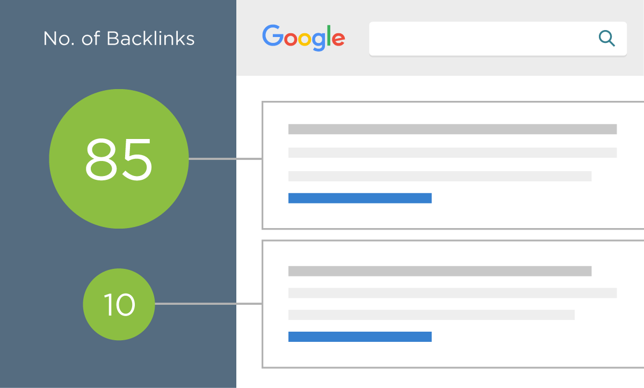
Today, the major search engines use many metrics to determine the value of external links. Some of these metrics include:
- The trustworthiness of the linking domain.
- The popularity of the linking page.
- The relevancy of the content between the source page and the target page.
- The anchor text used in the link.
- The number of links to the same page on the source page.
- The number of root domains that link to the target page.
- The amount of variations that are used as anchor text to links to the target page.
- The ownership relationship between the source and target domains.
In addition to these metrics, external links are important for two main reasons:

1. Popularity
Whereas traffic is a "messy" metric and difficult for search engines to measure accurately (according to Yahoo! search engineers), external links are both a more stable metric and an easier metric to measure. This is because traffic numbers are buried in private server logs while external links are publicly visible and easily stored. For this reason and others, external links are a great metric for determining the popularity of a given web page.

2. Relevancy
Links provide relevancy clues that are tremendously valuable for search engines. The anchor text used in links is usually written by humans (who can interpret web pages better than computers) and is usually highly reflective of the content of the page being linked to. Many times this will be a short phrase (e.g., "best aircraft article") or the URL of the target page (e.g., http://www.best-aircraft-articles.com).
The target and source page, as well as the domain cited in a link also provide valuable relevancy metrics for search engines. Links tend to point to related content. This helps search engines establish knowledge hubs on the Internet that they can then use to validate the importance of a given web document.

Ahrefs

We use a premium tool called Ahrefs to get insight into your backlink profile.
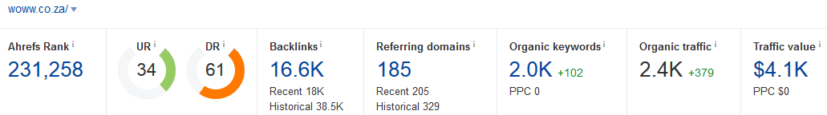
For the mini audit, Ahrefs is used to compare backlink strength, referring domains and link gaps against selected SEO competitors. The goal is to identify whether authority is likely holding the site back and where realistic backlink opportunities exist.

Every website is given an Ahrefs Rank, UR and DR

Ahrefs Rank (AR) shows the target website's position among all other websites in our database rated by the "strength" of their backlink profiles. The website with the strongest backlink profile is ranked #1

URL Rating (UR) shows the strength of the target URL's backlink profile on a 100-point logarithmic scale (higher = stronger). Both internal and external links influence this metric. NOTE: UR has a clear positive correlation with Google rankings, meaning that high-UR pages tend to rank higher in the organic search results. When the whole domain is analyzed in Site Explorer, URL Rating will be shown for the homepage.

Domain Rating (DR) shows the relative "backlink popularity" of the target website compared to all other websites in our database on a 100-point logarithmic scale (higher = stronger). We calculate DR based on the number of websites linking to the domain’s URLs and their backlink profile strength.

Both numbers scale logarithmically.

DATA COLLECTION: Client

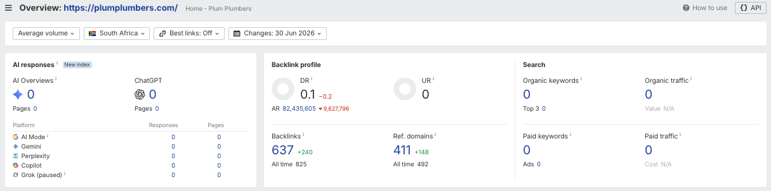

Competitors (Ahrefs Overview)
We chose your biggest competitors in terms of data. Ie: competitors who compete for similar terms and rank the highest on Google for your target audience. While these may not be your real life competitors, they are ranking for keywords and terms you want to rank for.

DATA COLLECTION

 | Keyword intersect - [your competitors have these keywords but you don’t]
 | Link intersect

DATA COLLECTION: The Cape Town Plumber

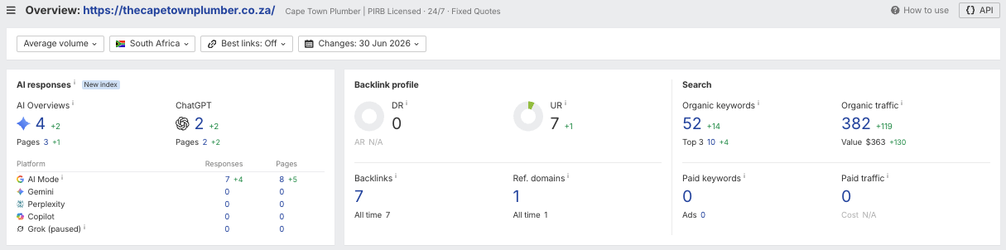

DATA COLLECTION: The Drain Surgeon

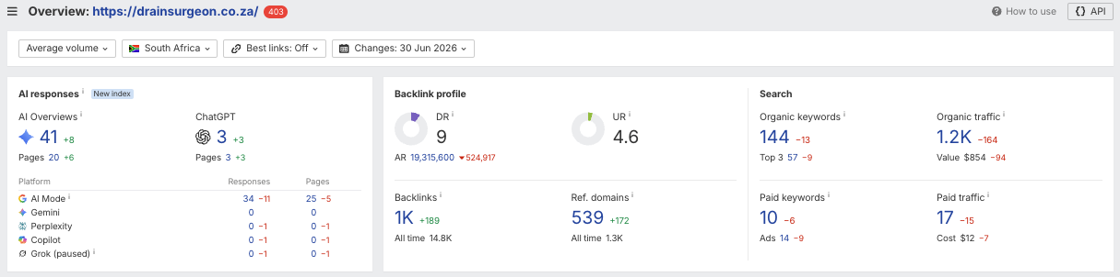

DATA COLLECTION: Schmidhauser

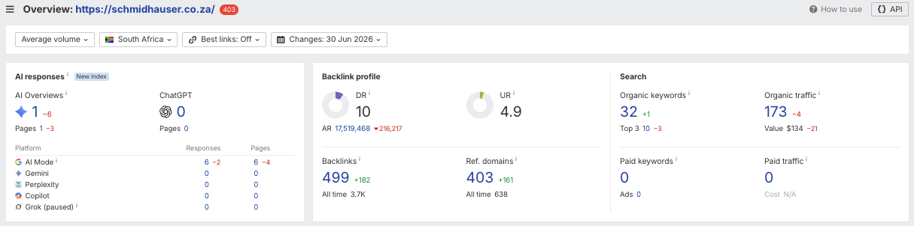

DATA COLLECTION: Absolute Plumbing

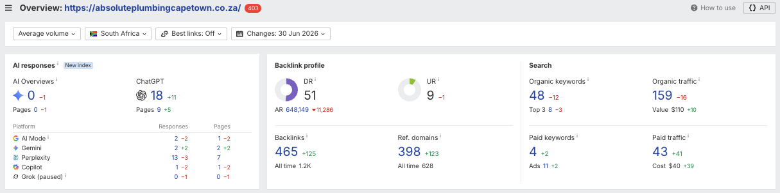

DATA COLLECTION

 | Backlinks
 | Backlink anchors
 | Referring domains
 | Link intersect [your competitors have these backlinks, but you don’t]
 | Keyword Intersect [your competitors have these keywords but you don’t]

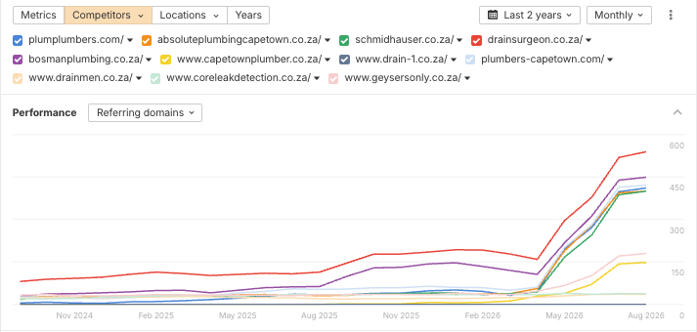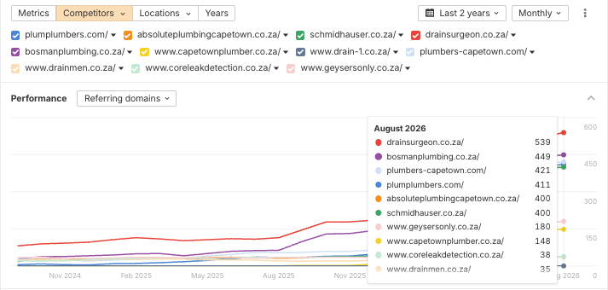

FINDINGS

- Your site has 414 referring domains (unique domains linking to your site) which together have produced 646 backlinks in the updated backlink data, including 82 followed backlinks from 36 followed referring domains.
- Plum Plumbers has a useful raw backlink footprint, but current rankings show those links are not yet translating into organic visibility.
- The gap is quality, relevance and page-level support rather than link volume alone. The link-intersect data should be used to prioritise credible local, supplier, trade, business and property-management opportunities that competitors have but Plum does not.
- N/A

RECOMMENDATIONS
Prioritise link building from relevant domains that already link to competitors, while continuing to protect the quality of the existing backlink profile. Focus on industry directories, suppliers, partners, publications and associations where a link would make sense for users as well as search engines.

Google My Business
An important first step in any local SEO strategy is to claim and verify your local business’s Google My Business (GMB) listing. Getting on Google My Business can increase your chances of showing up in Google’s Local Pack, Local Finder, Google Maps, and organic rankings in general.

Qualifying local businesses can claim a free listing on Google and include information about their company, such as their address, phone number, business hours, and types of payment accepted.

Additionally, over the past several months, Google has added some great features to Google My Business that companies should take advantage of to enhance their listings and help grab viewers’ attention - and can increase their rankings in local search results.

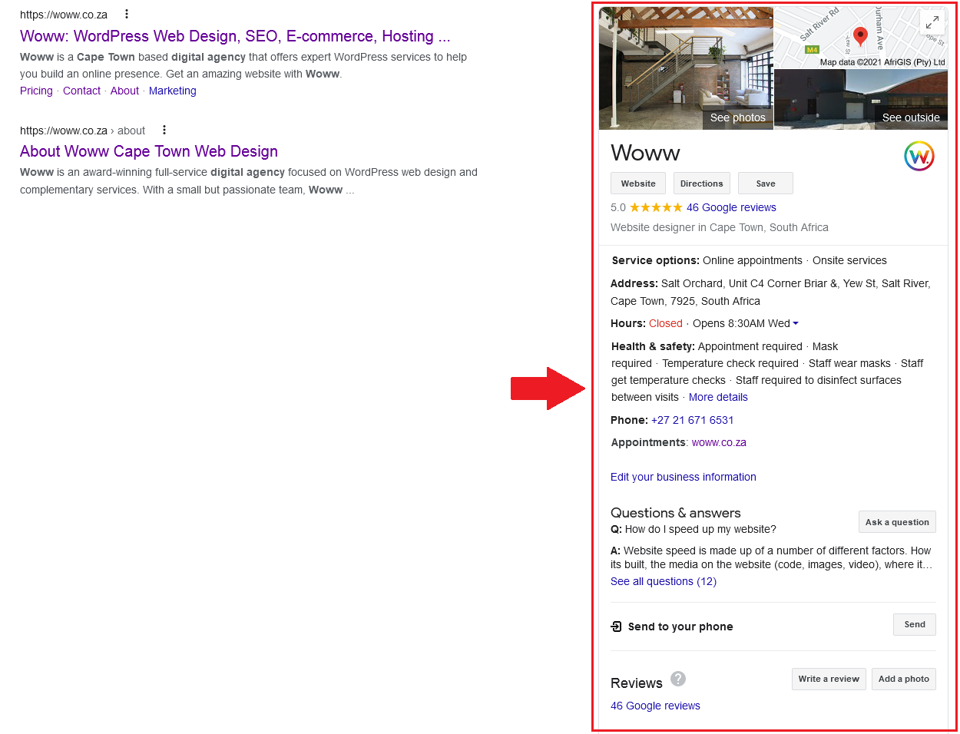
This is an example of the Woww Google My Business account. As you can see, it has useful information (such as contact info and hours) and a 5-star rating with a fair number of reviews.
FINDINGS

- Plum Plumbers has a visible Google Business Profile.
- It has 139 reviews and a 5.0-star rating
- The profile has between 15-20 images
- The phone number is listed
- Address is visible
- Operating hours are listed
- Frequently asked questions are missing from the profile
- Service categories are missing from the profile
- Services and service options are missing from the profile
- Posts section was last utilised in 2022
- Plum Plumbers’ 5.0 rating is a strong local trust asset, but its visible review count still sits behind larger GBP competitors such as Absolute Plumbing Cape Town, Schmidhauser and The Drain Surgeon.
- The Cape Town Plumber has a smaller visible review footprint, so Plum’s review strength is not the issue; the main comparison gap is review volume versus the larger local brands.
- The main profile gap is completeness: FAQs, service categories, service options and recent posts are missing, while competitors show stronger local-service targeting and more active trust signals.
- More current team, vehicle, job-site, before-and-after and service-specific photos can improve conversion confidence for emergency plumbing, geysers, leak detection and drain searches.
- Keep building recent reviews while improving profile completeness so Plum can compete on both rating quality and perceived local depth.
- The profile appears unclaimed
  - “Own this business?” link below the listing
    - Must claim business.

RECOMMENDATIONS
- Claim the profile
- Start publishing posts again that are based around your service offerings, service areas and any promotions.
- Add service categories and services, and populate them to align with all of your relevant offerings.
- Add frequently asked questions to the profile to answer questions around turnaround times/emergency plumbing if applicable to Plum Plumbers, and information around other services and questions that customers might have about them.
- Keep encouraging reviews from happy customers and maintain the current review score.
- When launching social media presences outside of Facebook and Instagram, ensure that you add these links to the profile.

We put together a spreadsheet with 4 competitors, measuring company context, content activity, SEO, backlink quality, local signals and social media. This gives insight beyond raw traffic or link counts.
This is to give some insight in comparing companies on more than just SEO data.

 | Initial Competitor Analysis
 | Detailed Competitor Analysis

ANALYSIS SUMMARY: https://www.plumplumbers.com/
- Plum Plumbers’ domain was registered on 8 August 2020, making it 5 years, 11 months and 29 days old as of 6 August 2026.
- The site currently has no blog footprint recorded and no dedicated keyword-led landing pages beyond broad service/project content.
- The crawl and keyword work indicate that the website is project-led rather than service-led, which limits its ability to rank for plumbing, emergency, geyser, leak detection and drain searches.
- Local trust is a strength: Plum has a 5.0 rating, visible contact details, operating hours and profile imagery.
- GBP gaps remain around FAQs, service categories, service options and recent posts.
- Image use should be expanded with more team, vehicle, job-site and service-specific visuals across GBP and the website.
- SEO metrics: DR 0.1, UR 0, 414 referring domains, 646 backlinks and 82 followed backlinks from 36 followed referring domains.
- The completed intersect data records no top-10 keyword rankings for Plum, despite the existing backlink footprint.
- The priority is to turn existing real-world capability into clear service pages, stronger internal linking, useful advice content and relevant local authority signals.

ANALYSIS SUMMARY: https://thecapetownplumber.co.za/
- The Cape Town Plumber is a very new domain, registered on 2 October 2025, yet it is already the clearest on-page/service-location benchmark.
- The site has a strong blog and landing-page footprint, including service pages, emergency plumbing pages, geyser pages and suburb targeting.
- It ranks for high-intent Plum-relevant terms including plumber Cape Town #3, plumbers Cape Town #4, emergency plumber #5 and 24 hour plumber Cape Town #6.
- SEO metrics: DR 0, UR 7, 1 referring domain, 7 backlinks and 51 top-10 keyword rankings.
- Its performance shows that clear intent matching and page structure can work even without meaningful domain authority.
- GBP/review footprint is smaller than Plum’s, so this competitor is stronger as a page-structure benchmark than as a local-review benchmark.
- Plum should use this competitor as a practical model for service/suburb architecture, not as a link-building benchmark.
- The transferable lesson is focused service intent, direct CTAs and scalable local landing pages.

ANALYSIS SUMMARY: https://schmidhauser.co.za/
- Schmidhauser has a long-established domain, registered on 3 August 2005, and offers construction, electrical and plumbing services.
- Its plumbing page covers maintenance, repairs, 24-hour callouts, blocked pipes/drains, leak detection, geyser replacement, COCs, drain jetting and burst pipes.
- It ranks for relevant Plum opportunities including plumbing companies in cape town #2 (Vol 150, KD 6), plumbing companies #3 (Vol 150, KD 19), plumbers in cape town #4 (Vol 150, KD 0), plumbers cape town #5 (Vol 200, KD 0) and plumber cape town #5 (Vol 350, KD 0).
- SEO metrics: DR 10, UR 4.9, 410 referring domains, 515 backlinks, 108 followed backlinks from 18 followed referring domains and 40 top-10 keyword rankings.
- Schmidhauser’s local profile is a stronger review-volume benchmark than Plum, with a 4.6 rating and a much larger review footprint recorded in the completed sheet.
- Schmidhauser is a useful benchmark for mixed plumbing/electrical authority, but its limited service-location depth means Plum can compete with more focused commercial pages.
- The key takeaway is to build service pages that are more specific and conversion-led than Schmidhauser’s broader group-service structure.
- Plum should treat Schmidhauser as a credibility benchmark, not a final model for service-page depth.

ANALYSIS SUMMARY: https://drainsurgeon.co.za/
- The Drain Surgeon has the oldest domain in the detailed set, registered on 9 July 2002, and operates as a national emergency plumbing/franchise brand.
- It is the strongest organic visibility benchmark, with branch/location and service targeting for emergency plumbing, blocked drains, CCTV drain inspections, jetting, pipe relining, geysers and leak detection.
- It ranks for major Plum-relevant terms including emergency plumbers #1, blocked drain #1, burst geyser #1 and emergency plumber #2.
- SEO metrics: DR 9, UR 4.6, 410 referring domains, 1,029 backlinks, 431 followed backlinks from 118 followed referring domains and 188 top-10 keyword rankings.
- Its local profile is a meaningful trust benchmark, with a 4.8 rating and a larger review footprint than Plum in the completed sheet.
- Plum should use The Drain Surgeon as the benchmark for emergency, drain and geyser intent, while recognising that its national/franchise footprint is broader than Plum’s current site.
- The transferable lesson is clear service clustering around urgent problems, not trying to match the national brand footprint.
- Plum should create focused Cape Town pages for emergency plumbing, blocked drains, geysers and leak detection before expanding into thinner support content.

ANALYSIS SUMMARY: https://absoluteplumbingcapetown.co.za/
- Absolute Plumbing Cape Town has a mature domain, registered on 15 September 2014, and the strongest authority score in the selected competitor set.
- Its site has the broadest service/suburb footprint, including plumbing, renovations, drain cleaning, leak detection, pipe relining, geysers, heat pumps, commercial plumbing and utility location.
- It ranks for relevant terms including geyser repairs near me #4 (Vol 250), water leak detection #10 and plumber fish hoek #3.
- SEO metrics: DR 51, UR 9, 401 referring domains, 485 backlinks, 69 followed backlinks from 19 followed referring domains and 40 top-10 keyword rankings.
- Absolute has the strongest review footprint in the set, with a 5.0 rating and a very high recorded review count.
- Absolute is the strongest benchmark for authority, review footprint and service-page breadth, but its organic traffic is still lower than The Drain Surgeon and The Cape Town Plumber.
- Plum should use Absolute as a benchmark for service coverage and trust depth, not as a reason to chase domain authority before fixing page relevance.
- The key takeaway is to pair broader service coverage with proof, FAQs and internal links so those pages can convert as well as rank.

RECOMMENDATIONS
- Prioritise high-intent service pages before expanding low-value blog output.
- Build pages for core plumbing, emergency plumbing, blocked drains, leak detection, geyser installation, geyser repairs and any confirmed electrical, air-conditioning or refrigeration services.
- Start with Cape Town service intent and then build selective suburb pages only where Plum can add real local proof.
- Give each service page a unique H1, service-specific evidence, clear enquiry CTA, FAQs and internal links to related services or projects.
- Improve core metadata: add missing meta descriptions, strengthen thin titles and make each page’s search intent clear.
- Use clear heading hierarchy and add supporting sections that answer customer concerns around response times, costs, qualifications, process and service areas.
- Start a sustainable Advice/FAQs programme aligned to useful plumbing questions: burst pipes, blocked drains, leaks, geysers, emergency callouts, aircon servicing and refrigeration faults.
- Use The Cape Town Plumber as the clearest benchmark for service/suburb page structure and intent matching.
- Use The Drain Surgeon as the benchmark for emergency, drain and geyser clusters.
- Use Schmidhauser as the benchmark for mixed plumbing/electrical credibility and COC-related content where Plum is qualified to offer those services.
- Use Absolute Plumbing Cape Town as the benchmark for authority, review depth and broader service coverage.
- Improve internal links from the homepage, services hub, project pages, advice content and service-area pages using descriptive anchor text.
- Add original images and meaningful alt text to commercial service, project and service-area pages.
- Add appropriate structured data to key service pages, following the Technical Audit’s guidance.
- Improve conversion paths: show trust signals, reviews, service FAQs and a consistent request-a-callback or emergency-contact CTA.
- Build higher-quality local, supplier, trade, business-directory and property-management links to support the new pages.
- Keep GBP service categories, services, hours and website service pages aligned.
- Add live social links to the website only for profiles Plum can realistically maintain.
- Use social posts to amplify new service pages, advice resources, project proof, reviews and local trust signals.
- Track organic traffic, top-10 keywords, local rankings, referring-domain quality, GBP review growth and enquiries monthly.
- Use the completed Content and Technical Audits to sequence work and avoid duplicated effort.

Social Media
lSOCIAL MEDIA &l lSOCIAL SIGNALSl
This section reviews Plum Plumbers’ social presence and how it supports trust, local visibility, content distribution and conversion. The audit focuses on whether live social profiles are linked from the website, whether channels are active enough to support the brand, and how competitors use social content such as Reels, project proof and practical advice.

Studies have concluded that Social signals are included as a ranking factor, we outline and identify your social presence and the impact it’s having on your SEO.

SOCIAL SUMMARY:
Plum Plumbers: https://www.plumplumbers.com/
- Social icons are not present on the site, so users cannot easily move from the website to active social proof.
- Facebook activity was not found as an active account in the completed competitor sheet.
- Instagram has 184 followers, but the last observed post was 99 weeks ago.
- LinkedIn is not recorded for Plum, limiting business trust signals for commercial and property-management audiences.
- YouTube has 2 subscribers, 6 videos and 820 total views; the last video was posted around four years ago.
- Social activity is currently too limited to provide a meaningful advantage in trust, content distribution or local visibility.

SOCIAL SUMMARY:
The Cape Town Plumber: https://thecapetownplumber.co.za/
- Facebook is very active, with roughly 20-30 July posts, Reels and typical video views in the 100-400 range.
- TikTok has 970 followers and 2,731 likes, with activity mirroring the Facebook cadence.
- No Instagram, LinkedIn, YouTube or X/Twitter account was recorded.
- The Cape Town Plumber is the clearest benchmark for using frequent short-form social content to support a new service-led site.
- Its main advantage is consistency and visibility rather than follower scale.

SOCIAL SUMMARY:
Schmidhauser: https://schmidhauser.co.za/
- Facebook has around 18,000 followers, 8-10 posts per month, Reels and engagement commonly in the 10-30 range.
- Instagram has 557 followers and a large media footprint, though the sheet needs manual validation for exact cadence and engagement fields.
- LinkedIn has 247 followers and around four posts per month, which supports commercial credibility.
- TikTok has 366 followers and 2,400 likes, with most videos in the 1,000-5,000 view range and several stronger performers.
- Schmidhauser is the strongest benchmark for social breadth and established local trust signals.

SOCIAL SUMMARY:
The Drain Surgeon: https://drainsurgeon.co.za/
- Facebook activity is present through Cape Town and broader branch profiles; the Cape Town page has around 515 followers and Reels.
- Instagram has 781 followers and roughly 8-15 posts per month.
- YouTube has 26 subscribers, 20 videos and 531,986 total views, largely helped by older TV-ad style videos.
- X/Twitter exists but appears inactive, with the last observed post in 2015.
- The Drain Surgeon shows that brand visibility and video assets can support trust even when some channels are inactive.

SOCIAL SUMMARY:
Absolute Plumbing Cape Town: https://absoluteplumbingcapetown.co.za/
- Facebook has around 1.3k followers, Reels and video views that often sit between 50-300, with some videos above 1,000-2,000 views.
- Instagram has 511 followers but posting appears sporadic.
- YouTube has one video, 5 subscribers and 110 total views.
- LinkedIn has 44 followers and no posts recorded.
- TikTok has 191 followers and 328 likes, with three posts and video views ranging from roughly 1,200-6,263.
- Absolute has stronger social proof than Plum, but its activity is uneven enough that Plum can compete with a focused, realistic cadence.

RECOMMENDATIONS
- Add live social links to the website footer once Plum has profiles it can realistically maintain.
- Use Instagram and YouTube as proof-led channels, and consider Facebook/TikTok only if Plum can sustain short-form job and advice content.
- Restart with a realistic cadence: two to four useful posts per month per priority channel before increasing volume.
- Use short-form video to explain common plumbing issues, emergency callouts, blocked drains, leaks, geyser faults, maintenance tips and project outcomes.
- Repurpose each new service page, FAQ or project into social posts that drive users back to the relevant page.
- Show trust: reviews, team members, vehicles, certifications, clear process steps, job-site proof and behind-the-scenes content.
- Use location-specific posts for Cape Town service areas only where there is genuine local work, imagery or proof to share.
- Use Reels, Shorts or TikTok where practical; The Cape Town Plumber and Schmidhauser show that short-form content can support local visibility and trust.
- Use LinkedIn lightly for commercial credibility, partnerships, recruitment, qualifications and project milestones.
- Use YouTube only when there is a repeatable supply of useful service, project or explainer video; do not create a channel simply to match competitors.
- Track follower growth, reach, engagement, video views, website clicks and assisted enquiries, then repeat formats that perform.


lSUMMARY &l lCONCLUSIONl

Summary & Conclusion
Plum Plumbers has a clear opportunity to rebuild organic visibility around high-intent Cape Town plumbing searches, because the completed audit shows real service capability but limited organic search capture at present.
The current keyword dataset shows no active rankings, while the 12-month comparison records lost visibility for terms including plumbers Cape Town, plumber Cape Town and 24 hour plumber Cape Town. This means the site has previously shown relevance for local plumbing searches, but no longer has enough focused content or SEO support to retain that visibility.
The present website is also not structured around the services customers search for. Of the 13 indexable pages found in the crawl, 10 are project, project archive or project-hub pages. Projects are valuable proof of experience, but they cannot carry the full responsibility for ranking across plumbing, emergency work, drains, leak detection, geysers and other service-led searches.
There is substantial demand across these themes. The research identified opportunities such as plumbing services, plumber Cape Town, emergency plumber, blocked drains, leak detection, geyser installation, geyser repairs and local suburb searches. Competitors are already visible for several of these terms, while Plum Plumbers currently has no dedicated service destinations for many of them.
The first priority should be to build the core service architecture. This means creating clear, conversion-focused Cape Town pages for each service Plum Plumbers actively provides and is qualified to deliver, supported by a Services hub, Commercial Services hub, Service Areas hub, Advice/FAQs hub and existing Projects hub.
The site also needs a stronger on-page foundation. All 13 indexable pages are missing meta descriptions, 11 pages have no H1 heading, two titles are too short, and 44 images across 144 image links have missing or generic alt text. These improvements will make it easier for search engines to understand each page and give users clearer reasons to click through from search results.
There are positive technical foundations to build on. The 404 page works adequately, no malware or internal server errors were detected, and layout stability is strong. However, mobile performance needs attention: the mobile PageSpeed score is 55/100, FCP and Speed Index are both 9.2 seconds, and LCP is 2.7 seconds. Google Analytics was set up during the audit, so it should now be used alongside Google Search Console to measure progress once data has accumulated.
Content creation should be purposeful. New advice articles and FAQs can capture informational searches around burst pipes, emergency plumbing costs, geyser problems, aircon servicing and refrigeration faults, then guide users towards the relevant service page. These should support the service architecture rather than become disconnected blog content.
Finally, Plum Plumbers should use the competitor, keyword-intersect and link-intersect research to build relevant authority. Competitors are already visible across plumbing, emergency plumbing, drains, geysers and leak detection searches, while Plum has backlink volume without comparable ranking visibility. A smaller number of well-developed service pages, useful advice resources, local proof and relevant backlinks will be more valuable than publishing large volumes of unsupported content.

Areas for Improvement

Here we will discuss the sections of this audit and what actions we suggest you take to address the problems.

technical
TECHNICAL | 10+ suggested actions
Plum Plumbers has a workable technical base, but the priority is to improve mobile performance, measurement and technical consistency before the service-led site architecture expands.
- Improve mobile loading performance by auditing non-essential theme, plugin and third-party assets; deferring non-critical JavaScript; removing unused CSS and scripts; and reducing unnecessary font files or weights.
- Review caching and CDN configuration so images, CSS and JavaScript are cached effectively. Retest from a South African location, targeting an LCP below 2.5 seconds, FCP below 1.8 seconds and CLS below 0.1.
- Use Google Analytics and Google Search Console to establish a performance baseline, then monitor organic clicks, enquiries, keyword visibility, service-page engagement and technical errors monthly.
- Confirm that all domain variations, trailing-slash versions and legacy URLs resolve consistently to one preferred canonical URL. Update internal links to point directly to final URLs rather than redirects.
- Add the missing security headers, including clickjacking protection, X-Content-Type-Options, Strict Transport Security and an appropriate Content Security Policy.
- Keep plugins, themes and WordPress core updated through a managed maintenance process, with backups taken before changes are applied.

content
CONTENT | 10+ suggested actions
The principal content issue is that the existing site is project-led rather than service-led. Project pages should remain as proof, but dedicated service pages must become the primary commercial destinations for the searches identified in the keyword research.
- Create a Services hub and one primary Cape Town page for every confirmed service, including core plumbing, emergency plumbing, blocked drains, leak detection, geyser installation, geyser repairs, and any confirmed electrical, air-conditioning or refrigeration services.
- Create electrical certificate-of-compliance pages only where Plum Plumbers is legally authorised to issue the relevant certification. Apply the same principle to air-conditioning, refrigeration and commercial services.
- Prioritise lower-difficulty, high-intent local opportunities first, including plumber Cape Town, plumbing services, 24 hour plumber Cape Town, blocked drain, water leak detection and geyser installation.
- Build selective suburb pages only after the main Cape Town service pages are live. Each should contain genuinely local proof, service-specific detail, availability information, reviews or relevant projects. Avoid mass-producing near-identical location pages.
- Add unique meta descriptions to every indexable page, descriptive H1 headings to the 11 pages currently missing them, and stronger titles for the homepage and About Us page.
- Replace missing and generic image alt text, particularly “client”, with concise descriptions of meaningful service and project imagery.
- Build an Advice/FAQs hub for useful informational searches, including burst-pipe costs, emergency-plumber pricing, leak issues, geyser faults, aircon servicing and refrigeration problems. Every article should link naturally to its relevant service page.
- Use the Projects hub as evidence of capability. Link individual project pages to the most relevant service pages so project content helps support commercial rankings.
- Maintain a keyword-to-page map. Assign one primary service and search intent to each URL to prevent overlap and future cannibalisation.

competitors
COMPETITORS | 10+ suggested actions
The competitive landscape shows that other Cape Town plumbing businesses already occupy important service-led searches, while Plum Plumbers currently has no comparable organic footprint in the completed intersect data.
- Use the selected competitor set as a practical benchmark: Absolute Plumbing Cape Town for authority and review depth, Schmidhauser for mixed plumbing/electrical credibility, The Drain Surgeon for emergency/drain/geyser intent, and The Cape Town Plumber for focused service/suburb page structure.
- Build pages that match the search intent competitors currently satisfy, rather than trying to rank a portfolio page for every service. A user searching for an emergency plumber, blocked drain or geyser installation needs a clear service page with trust signals and an enquiry route.
- Review the keyword-intersect data regularly to identify service terms competitors rank for that Plum Plumbers still does not target.
- Use the link-intersect research to build a shortlist of relevant backlink opportunities, prioritising credible local directories, industry associations, suppliers, property-management resources, business publications and partnership opportunities.
- Strengthen local trust signals on service pages through project evidence, qualifications, service areas, clear contact information, reviews and service-specific FAQs.
- Build links and relationships around useful resources and genuine business relevance. Avoid low-quality link schemes or generic directories that do not provide value to Cape Town customers.

Social Media
SOCIAL MEDIA | 15 suggested actions
Plum Plumbers’ social media presence is currently underused as a trust and distribution channel. The priority is to connect only active profiles, restart a realistic content cadence, and use social posts to support service pages, project proof, FAQs, reviews and local visibility.

- Add live social links to the website footer once Plum has profiles it can realistically maintain.
- Link only to active, maintained profiles; remove icons for channels that will remain dormant.
- Use Instagram and YouTube as proof-led channels, and consider Facebook/TikTok only if Plum can sustain short-form job and advice content.
- Start with a consistent two-to-four-post monthly cadence, then scale based on response.
- Create short-form videos answering practical plumbing questions, explaining emergency callouts, showing blocked drain/leak/geyser work, and demonstrating project outcomes.
- Use customer reviews, local service proof, staff/team content, vehicles, certifications and clear process education to build trust.
- Create location-specific posts for Cape Town service areas only where there is genuine local work, imagery or proof to share.
- Share new blogs, FAQs and location pages to give SEO content a distribution path.
- Use The Cape Town Plumber and Schmidhauser as benchmarks for accessible short-form video experimentation and consistent local visibility.
- Use The Drain Surgeon and Absolute Plumbing Cape Town as benchmarks for brand trust, service proof and selective video use.
- Use LinkedIn for partnerships, company news, recruitment and trust-building rather than high-frequency consumer posts.
- Only add YouTube when video production can be maintained with useful, searchable topics.
- Build a simple content calendar around plumbing FAQs, reviews, project proof, service-area updates, seasonal maintenance questions and new resources.
- Track follows, reach, engagement, video views, site clicks and attributed enquiries.
- Use performance data to refine format, cadence and subject matter each quarter.

